Module 3 - PL/SQL Programming
Exercise 3: Stored Procedures
Create table:
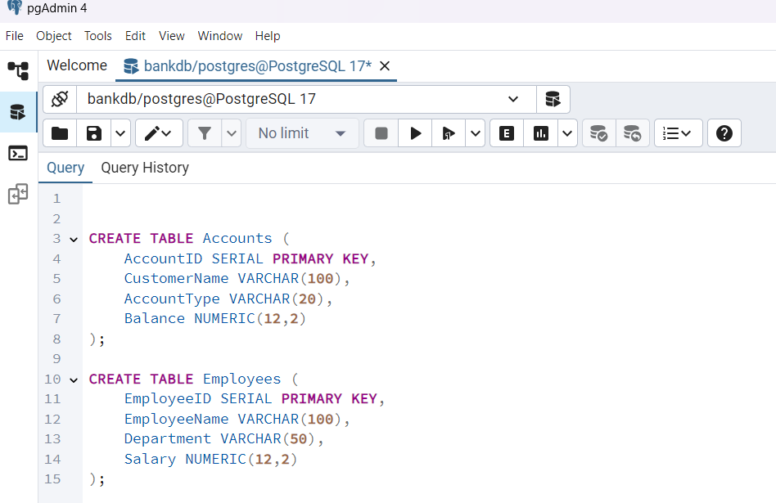
Insert sample data:
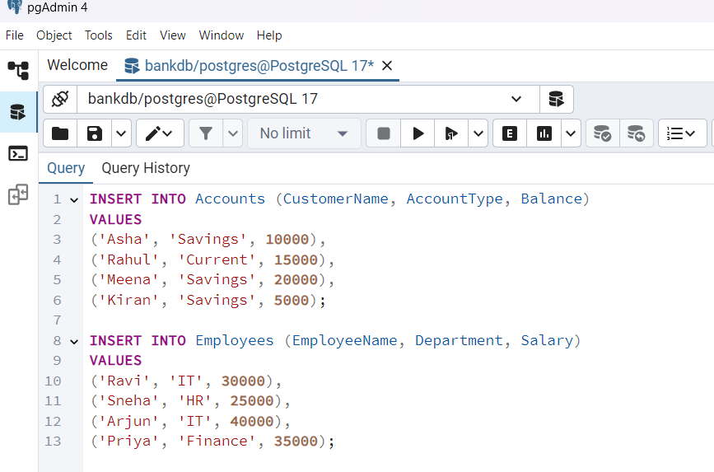
Scenario 1: Process Monthly Interest:
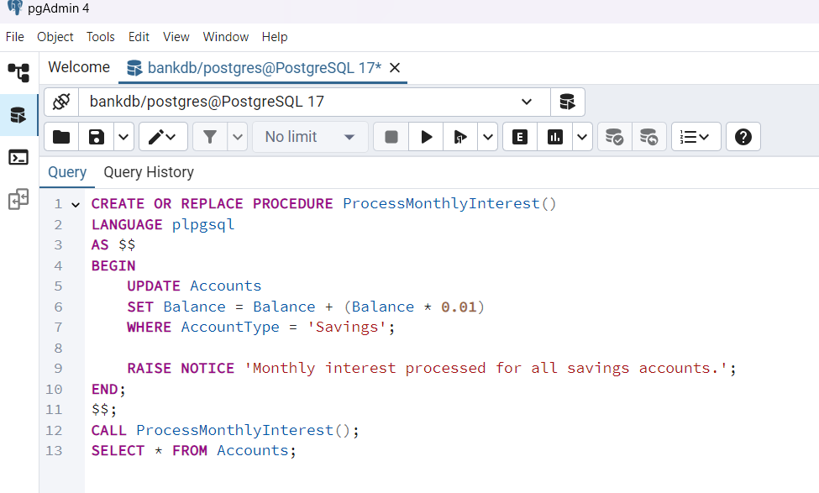
Output of scenario 1:
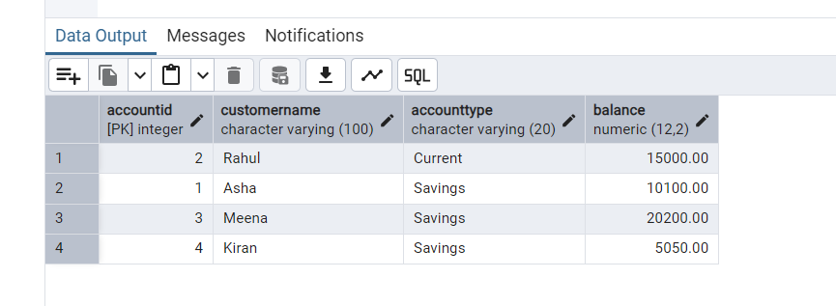
Scenario 2: Update Employee Bonus:
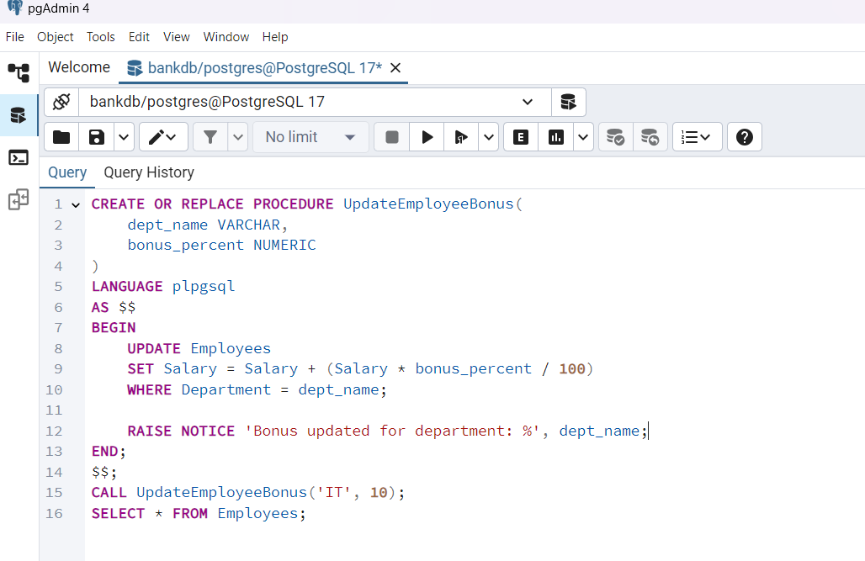
Output for scenario 2:
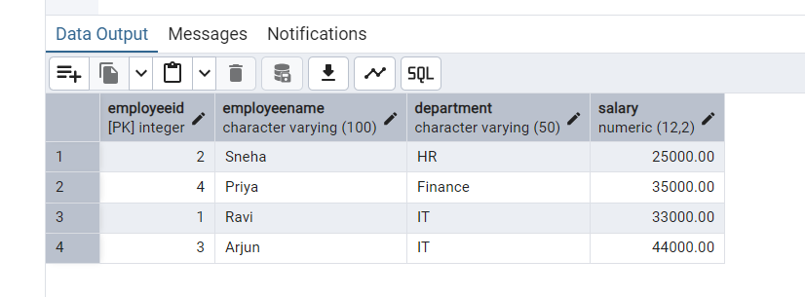
Scenario 3: Transfer Funds:
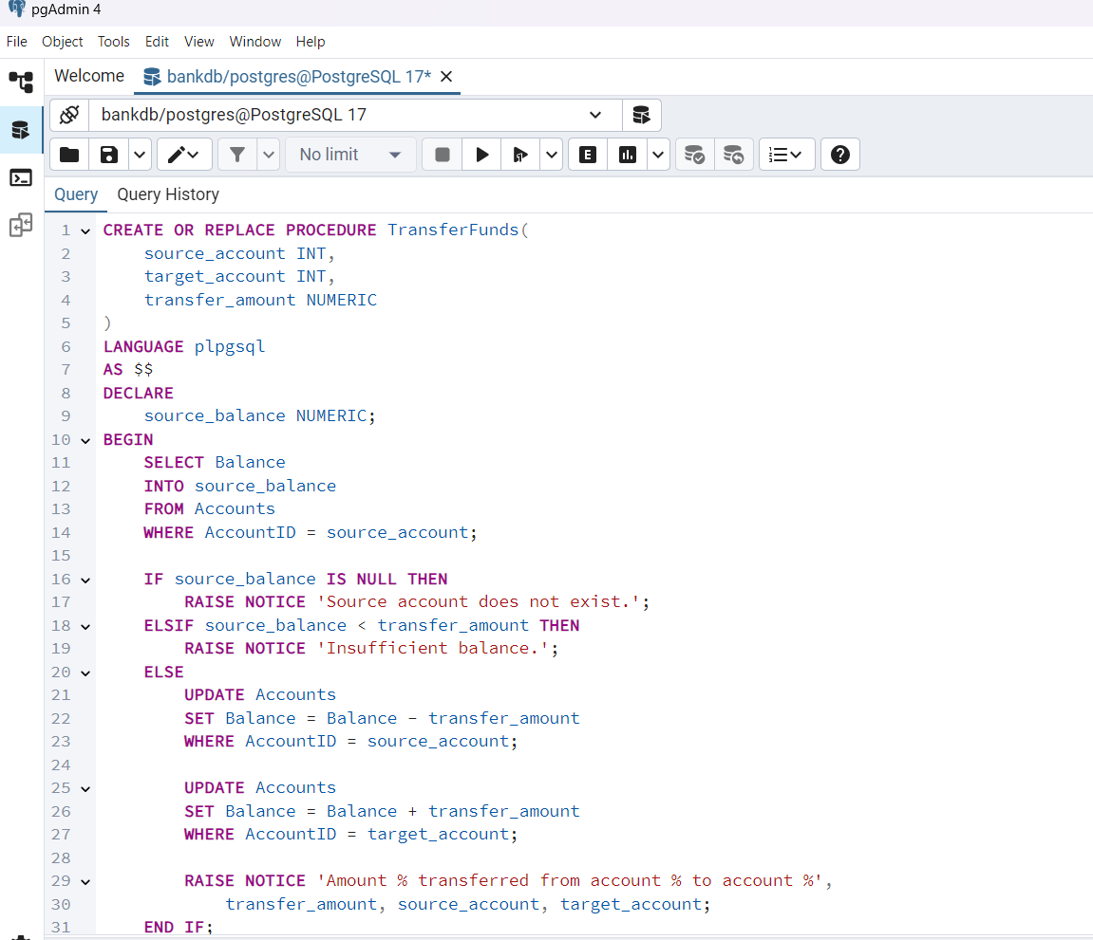
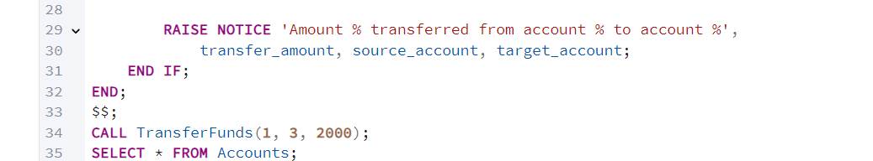

Output for scenario 3:
